1.gadget: from workbook FR Progress Check2.surplus: from workbook FR Progress Check 3.simultaneously: from workbook FR Progress Check4. Expenditure: from class yesterday 5. Firms: fromclass today (quite suspicous but exactly the same with the one in group chat,really)

1. gadget: from workbook FR Progress Check 2.surplus: from workbook FR Progress Check 3. simultaneously: from workbook FR Progress Check 4. Expenditure: from class yesterday 5. Firms: from class today
1. Terms of trade：from Unit1-1.3

2. marginal utility：from AP Question Bank-Demand/multiple choice question11A

3. the difference between （quantity demand/demand）and（quantity supply/supply）from AP Question Bank-Demand/multiple choice question14

4. future price：from Macro 1 UnitProgress Check-FromAP Website multiple choice question11

5. expenditure method：from today's class

price stability：from module two
consumption：from module four
castaway：from module four
inferior goods：from module five
surplus：from module six

1.supplylithium from PPT“unit1 summary”
2.taste from PPT“unit1 summary”
3.investment from today class
4.aggregate
5.expenditure

On the quiz:
critical expand welfare distribution idle unemployment

A general statement of the critical problem that can…… critical
People tend to expand their wants over time. Expand
providing citizens with welfare and social services welfare ；
distribution
idle resources idle
the unemployment rate decreased by 2 %last quarter unemployment
expendicure drawals transaction barter intermediate
- gadget: from workbook FR Progress Check 2.surplus: from workbook FR Progress Check 3. simultaneously: from workbook FR Progress Check 4. Expenditure: from class yesterday 5. Firms: from class today

Simultaneously
Feasible
Stocks
Inferior
Corresponding
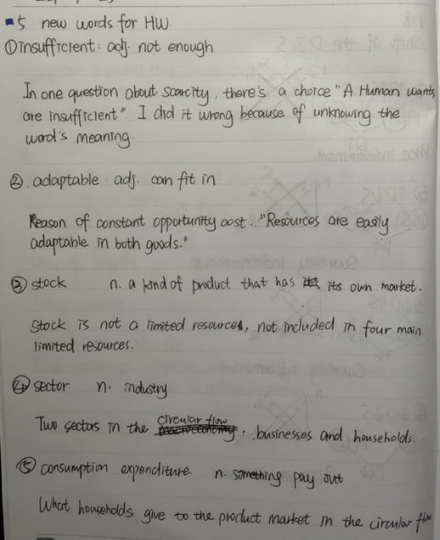
subside
giffen
unattainable
alternative
complement
(All the five vocabularies I am understand now)

transfer
institutions
investment
inventory
leakage
（They all come from the content of our class and the PPT. When I saw them for the first time, I was unfamiliar with them and did not understand them very well）

interest：on your ppt
aggregate：on the textbook
net：on workbook multiple choice question
expenditure：on your class

